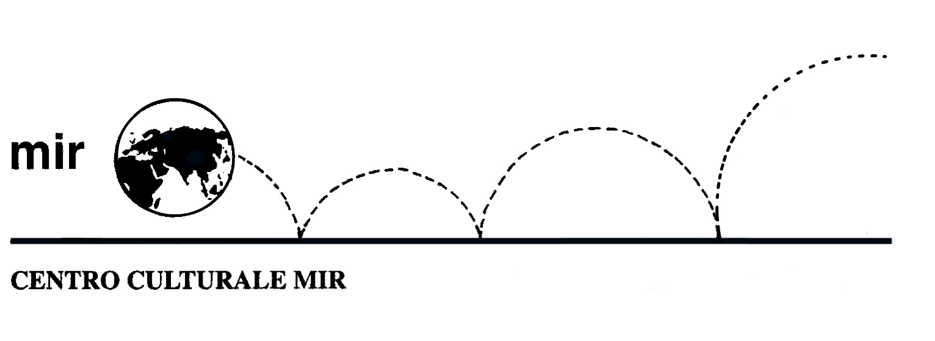

ENGLISH FILM FESTIVAL

Tuesday 10 June 08.30 p.m.
The Great Gatsby (2013)
143 min
Stars: Leonardo Di Caprio, Tobey Maguire

This film is beautiful in every way. The Great Gatsby is set in the jazz age, the 1920's. It tells the fictional story of an enigmatic and lonely millionaire named Jay Gatsby, who has been in love with the same woman for years and tries to win her back.

Tuesday 17 June 08.30 p.m.
Secrets and Lies (1996)
142 min
Stars: Brenda Blethyn, Timothy Spall, Phyllis Logan

Secrets & Lies is a 1996 British drama film written and directed by Mike Leigh. Led by an ensemble cast consisting of many Leigh regulars, it stars Marianne Jean-Baptiste as Hortense, a well-educated black middle class London optometrist, who was adopted as a baby and has chosen to trace her family history – only to discover that her birth mother, Cynthia, played by Brenda Blethyn, is a working class white woman with a dysfunctional family. Claire Rushbrook co-stars as Cynthia's other daughter Roxanne, while Timothy Spall and Phyllis Logan portray Cynthia's brother and sister-in-law, the latter of which have secrets of their own affecting their everyday family life.

Tuesday 24 June 08.30 p.m.
Monsters, Inc. (2001)
92 min

A very funny and kind animated film about an imaginary city of monsters with no humans called Monstropolis. The lovable, confident, furry blue giant monster named Sulley and his sarcastic best friend, green monster Mike Wazowski, discover what happens when the real world interacts with theirs in the form of a 2-year-old baby girl "Boo," who accidentally sneaks into the monster world with Sulley one night.
Full of twists and hilarious dialogues.

presso la sede di Corso Cavallotti 19 - Novara

